**Intelligent Handwritten Digit identification system for Computer Applications Using IBM Watson Studio**

**1.Introduction:**

*a. Overview:*

Handwriting recognition is one of the compelling research works going on because every individual in this world has their own style of writing. It is the capability of the computer to identify and understand handwritten digits or characters automatically. Because of the progress in the field of science and technology, everything is being digitalized to reduce human effort.Hence, there comes a need for handwritten digit recognition in many real-time applications. MNIST data set is widely used for this recognition process and it has 70000 handwritten digits. We use Artificial neural networks to train these images and build a deep learning model. Web application is created where the user can upload an image of a handwritten digit. this image is analyzed by the model and the detected result is returned on to UI.

*b. Purpose:*

More and more people are focusing on the use of the personal computer rather than acquiring excellent handwriting skills. The one reason is that the internet and applications are becoming more intelligent than before.The handwritten digit recognition is the ability of computers to recognize human handwritten digits. It is a hard task for the machine because handwritten digits are not perfect and can be made with many different flavors. The handwritten digit recognition is the solution to this problem which uses the image of a digit and recognizes the digit present in the image.A handwritten digit recognition system was used in a demonstration project to visualize artiﬁcial neural networks.

**2.Literature Survey:**

*a. Existing Problem:*

These days, an ever-increasing number of individuals use pictures to transmit data.In this the handwritten digits from its images are given as input, but the handwritten digits are not of the same size, thickness, style, and orientation, therefore, these problems are to be solved. In general, the field of digit recognition, one of the difficult undertakings is the precise computerized recognition of human handwriting. Without a doubt, this is a very difficult issue because there is an extensive diversity in handwriting from an individual to another individual. In spite of the fact that, this difference does not make any issues to people, yet, anyway it is increasingly hard to instruct computers to interpret general handwriting.

*b. Proposed Solution:*

The goal of this project is to create a model that will be able to recognize and determine the handwritten digits from its image by using the concepts of Convolution Neural Network.The major goal of the proposed system is understanding Convolutional Neural Network, and applying it to the handwritten digit recognition system.In the proposed system MNIST data set is widely used for this recognition process and it has 70000 handwritten digits.Artificial neural networks is used to train these images and build a deep learning model.Accuracy of about 97% can be achieved.

**3.Theoretical Anaylsis**:

*Technical Architecture:*

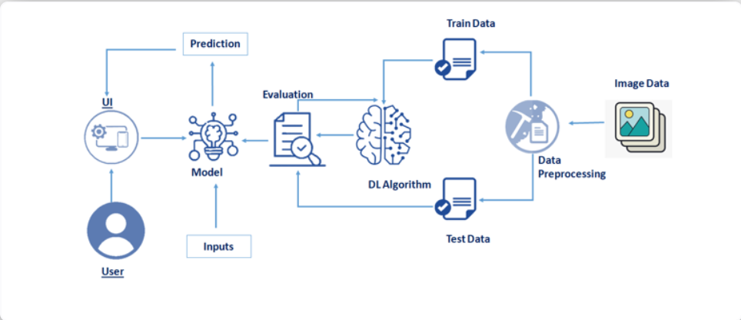

1. *Block Diagram:*

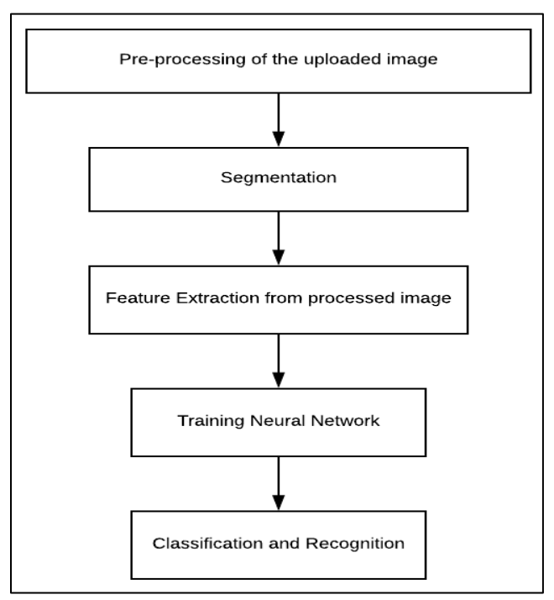

***Block Diagram***

1. *Hardware Designing:*

Windows - 7 or newer

Processor - intel core i3 or above or equivalent.

Hard disk - 20 GB

RAM -         1 GB or more

1. *Software Designing:*

➤ *Anaconda Navigator :*

Anaconda Navigator is a free and open-source distribution of the Python and R programming languages for data science and machine learning related applications. It can be installed on Windows, Linux, and macOS.Conda is an open-source, cross-platform,  package management system. Anaconda comes with so very nice tools like JupyterLab, Jupyter Notebook,QtConsole, Spyder, Glueviz, Orange, Rstudio, Visual Studio Code. For this project, we will be using Jupiter notebook and spyder.

➤ *Tensor flow:*

TensorFlow is an end-to-end open-source platform for machine learning. It has a comprehensive, flexible ecosystem of tools, libraries, and community resources that lets researchers push the state-of-the-art in ML and developers can easily build and deploy ML powered applications.

➤ *Keras :*

Keras leverages various optimization techniques to make high level neural network API easier and more performant. It supports the following features:

* Consistent, simple and extensible API.
* Minimal structure - easy to achieve the result without any frills.
* It supports multiple platforms and backends.
* It is user friendly framework which runs on both CPU and GPU.
* Highly scalability of computation.

➤ *Python 3.7 :*

Python is broadly utilized universally and is a high-level programming language. It was primarily introduced for prominence on code, and its language structure enables software engineers to express ideas in fewer lines of code. Python is a programming language that gives you a chance to work rapidly and coordinate frameworks more effectively.

**4.Experimental Investigations:**

➤ *Neural Networks:*

Artiﬁcial neural networks, usually called neural networks (NNs), are systems composed of many simple processing elements (neurons) operating in parallel whose function is determined by network structure, connection strengths, and the processing performed at computing elements or nodes. NNs exist in many varieties, though they can be categorized into two main groups, where the distinction lies in the learning method:

–supervised learning: the network is trained with examples of input and de-

sired output.

–unsupervised learning: the network tries to organize the input data in a

useful way without using external feedback.

➤ The user interacts with the UI (User Interface) to upload the image as input.The uploaded image is analyzed by the model which is integrated.Once the model analyses the uploaded image, the prediction is showcased on the UI.To accomplish this, we have to complete all the activities and tasks listed below

* Understanding the data.
  + Importing the required libraries

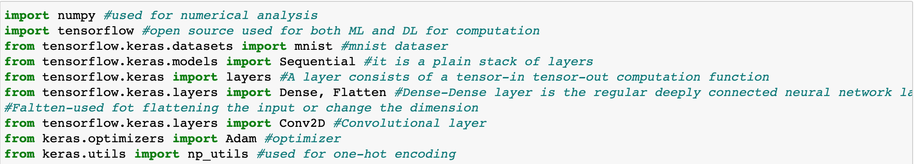

* + Loading the data



We split the data into train and test. Using the training dataset we train the model and the testing dataset is used to predict the results.



* + Analyzing the data
  + Reshaping the data.

As we are using Deep learning neural network, the input for this network to get trained on should be of higher dimensional. Our dataset is having three-dimensional images so we have to reshape them too higher dimensions 

* + Applying One Hot Encoding

**5.Flowchart:**

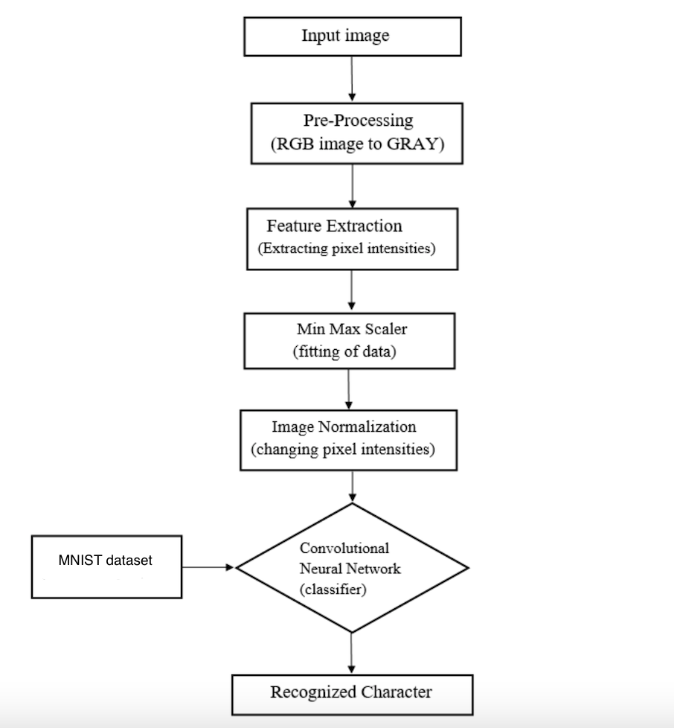

**6.Result:**

ML depends heavily on data, without data, it is impossible for a machine to learn. In Machine Learning projects, we need a training data set. It is the actual data set used to train the model for performing various actions. TensorFlow already has MNist Data set so there is no need to explicitly download or create Dataset .The MNSIT dataset contains ten classes: Digits from 0-9. Each digit is taken as a class.

* + Creating the model and adding the input, hidden and output layers to it.

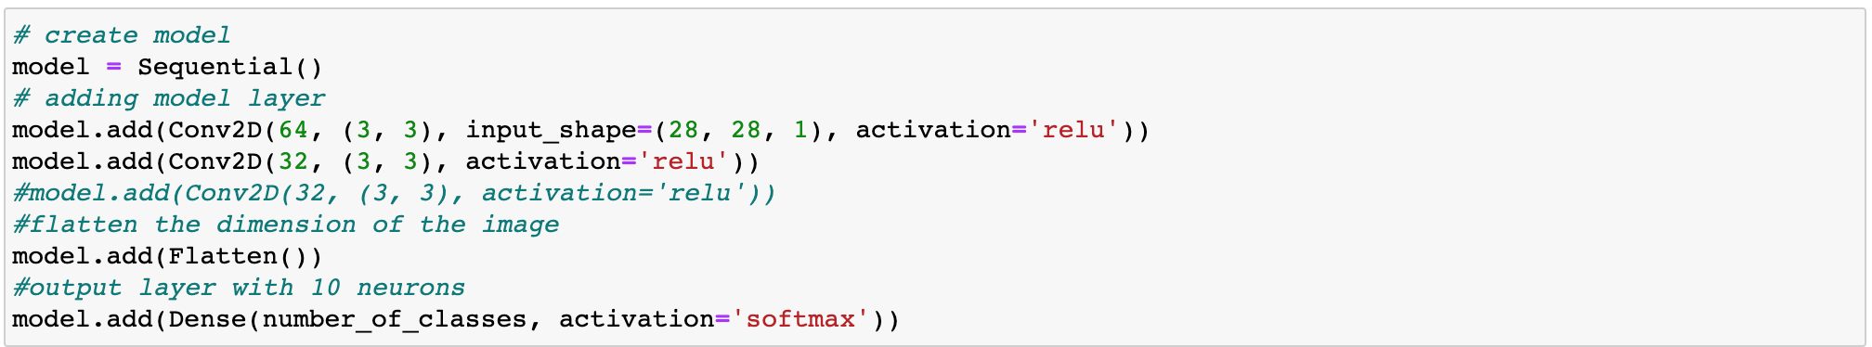

* + Compiling the model
  + Training the model
  + Predicting the result

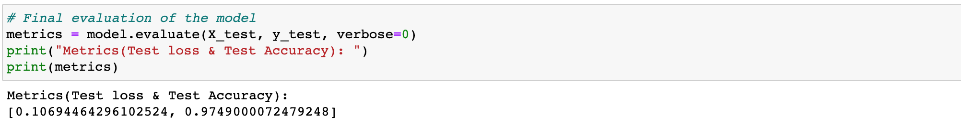

* + Testing the model by taking image inputs

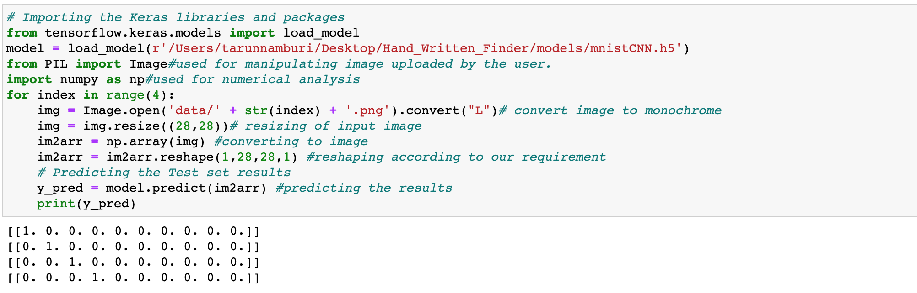

* + Saving the model

**7.Advantages & Disadvantages:**

*Advantages:*

* The system not only produces a classification of the digit but also a rich description of the instantiation parameters which can yield information such as the writing style.
* The generative models can perform recognition driven segmentation.
* The method involves a relatively small number of parameters and hence training is relatively easy and fast.
* Through the training phase, the system can adapt to the writing style of the user.

*Disadvantages:*

* The user needs patience because the learning process can take longer in some circumstances.
* The user has to learn a new way of writing.
* Not good for the system,where large variations exists in handwritting.
* Requires very large amount of training data.

**8.Applications:**

Handwritten digit recognition is one of the practically important issues in digit recognition applications. The applications of digit recognition includes

* Postal mail sorting
* Bank check processing
* Formation of data entry
* Number plate recognition

**9.Conclusion:**

The handwritten digit recognition system was tested on several different scanned images containing handwritten text with different styles and the results were highly encouraging.The dataset used for the experiment is MNIST dataset originally have 60000 images, and in the test  set we have 10000 images. The most widely used Machine learning algorithm, CNN have been trained and tested on the same data in order acquire the comparison between the classifiers. Utilising these deep learning techniques, a high amount of accuracy can be obtained. Using Keras as backend and Tensorflow as the software, a CNN model is able to give accuracy of about 97.49%.

**10.Future Scope:**

Recently handwritten digit recognition becomes vital scope and it is appealing many researchers because of its using in variety of machine learning and computer vision application.

* Increase the accuracy further by implementing more number of hidden layers and/or epochs.
* Detect custom handwritten digits.
* Use CNN with less layers to get better accuracy.

**11.Bibliography:**

1. M. Wu and Z. Zhang, Handwritten Digit Classification using the MNIST Dataset, 2010.
2. A. Dutta and A. Dutta, Handwritten digit recognition using deep learning, International Journal of Advanced Research in Computer Engineering & Technology (IJARCET), vol. 6, no. 7, July 2017.
3. Gaurav Jain, Jason Ko, Handwritten DigitsRecognition, Project Report, University of Toronto, 11/21/2008.
4. Hamid, Norhidayu Abdul, and NilamNur Amir Sjarif,Handwritten recognition using SVM, KNN and neural network, arXiv preprint arXiv:1702.00723 (2017).
5. R.G.Mihalyi, Handwritten digit classification using support vector machines, 2011.

**12.Appendix:**

*a. Source Code:*

In this section, we will be building a web application that is integrated into the model we built. A UI is provided for the uses where he has uploaded an image. The uploaded image is given to the saved model and prediction is showcased on the UI.

This section has the following tasks

* Building HTML Pages
* Building server-side script

Let us build the flask file ‘app.py’ which is a web framework written in python for server-side scripting. Let’s see step by step procedure for building the backend application.

* App starts running when the “__name__” constructor is called in main.
* render_template is used to return HTML file.
* “GET” method is used to take input from the user.
* “POST” method is used to display the output to the user.

# -*- coding: utf-8 -*-

"""

Created on Thu Sep 24 13:39:41 2020

@author: DELL

"""

from flask import Flask, render_template, request# Flask-It is our framework which we are going to use to run/serve our application.

#request-for accessing file which was uploaded by the user on our application.

from PIL import Image #used for manipulating image uploaded by the user.

import numpy as np #used for numerical analysis

from tensorflow.keras.models import load_model#to load our model trained with MNIST data

import tensorflow as tf#to run our model.

app = Flask(__name__) #our flask app

model = load_model("/Users/tarunnamburi/Desktop/Hand_Written_Finder/models/mnistCNN.h5") #loading the model

@app.route('/') #default route

def upload_file():

   return render_template('main.html') #rendering html page

@app.route('/about') #Main page route

def upload_file1():

   return render_template('main.html') #rendering html page

@app.route('/upload') #main page route

def upload_file2():

   return render_template('index6.html')

@app.route('/predict', methods = ['POST']) #route for our prediction

def upload_image_file():

   if request.method == 'POST':

      img = Image.open(request.files['file'].stream).convert("L")# convert image to monochrome

      img = img.resize((28,28))# resizing of input image

      im2arr = np.array(img)#converting to image

      im2arr = im2arr.reshape(1,28,28,1) #reshaping according to our requirement

      y_pred = model.predict_classes(im2arr) #predicting the results

      print(y_pred) #printing our result in prompt

      #return 'Predicted Number: ' + str(y_pred) #returning our output

      if(y_pred == 0) :

        return render_template("0.html",showcase =  str(y_pred))

      elif(y_pred == 1) :

        return render_template("1.html",showcase =  str(y_pred))

      elif(y_pred == 2) :

        return render_template("2.html",showcase =  str(y_pred))

      elif(y_pred == 3) :

        return render_template("3.html",showcase =  str(y_pred))

      elif(y_pred == 4) :

        return render_template("4.html",showcase =  str(y_pred))

      elif(y_pred == 5) :

        return render_template("5.html",showcase =  str(y_pred))

      elif(y_pred == 6) :

        return render_template("6.html",showcase =  str(y_pred))

      elif(y_pred == 7) :

        return render_template("7.html",showcase =  str(y_pred))

      elif(y_pred == 8) :

        return render_template("8.html",showcase =  str(y_pred))

      else :

        return render_template("9.html",showcase =  str(y_pred))

   else:

        return None

if __name__ == '__main__':

    app.run(host='0.0.0.0', port=8000,debug=True)

   #app.run(debug = True) #running our flask app

*b. UI output Screenshot:*

* Open anaconda prompt from the start menu
* Navigate to the folder where your python script is.
* Now type “python app.py” command

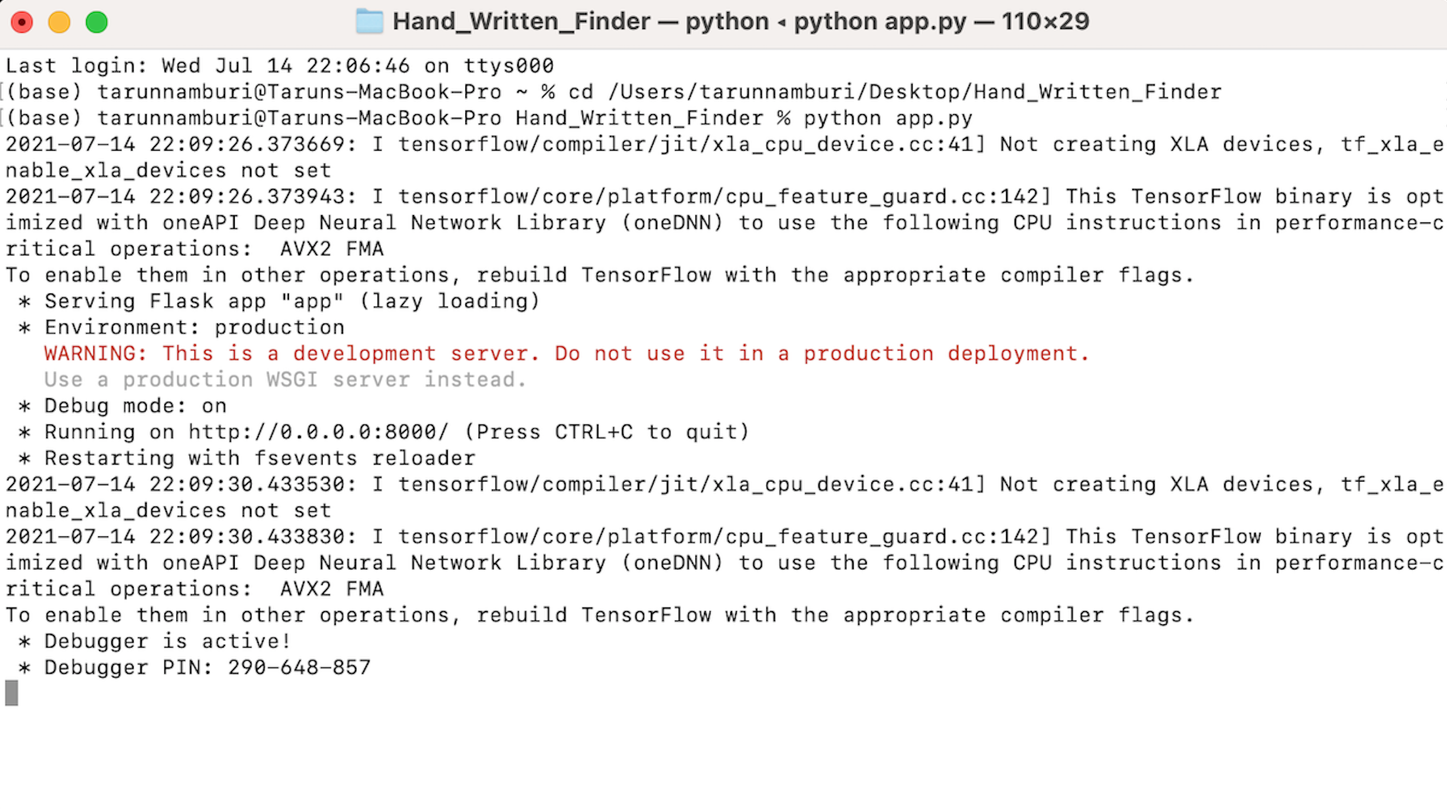

Navigate to the localhost where you can view your web page and Upload an image and see the predicted output on UI your page and output looks like:



